D. SUMMARY OF DEMOGRAPHIC TRENDS AND CIVIC NEEDS
The Gloucester Lyceum and Sawyer Free Library seeks to align its work to both the changing environment in which it exists and to the community’s current needs and expectations. This alignment is required in order for the library to remain integral to the future of the Gloucester.
THE LOCAL PICTURE
Population Trends
Gloucester’s population of individuals aged 60+ has grown steadily since 2010 and will continue to grow. According to the U.S. Census, the median age of all people in Gloucester is 49.5, significantly higher than the Massachusetts median age of 39.5. This reflects a national trend and introduces many new opportunities for the library to extend its services to this growing population.
Incomes
The median household income in Gloucester is $61,505 which is significantly above the national median of $53,889. But there is a stark disparity in the distribution of wealth. Residents in Lanesville, Magnolia and East Gloucester each have approximately twice the average household income, $37,000 of residents in Downtown. Additionally, Gloucester’s median household income is significantly lower than both the state median of $68,563 and the Essex County median of $70,866 (US Census).
Ethnic Distribution
While 94% of Gloucester’s population is white, trends show that it is slowly diversifying (down from 98% white in 2010). At least 11% of the population speaks a language other than English at home. As with libraries across the nation, the library needs to recognize the growing diversity in the population and tailor services to meet the needs of more diverse users. In addition to hosting Wellspring House’s English language classes, growing collections in first languages, and developing Portuguese story times, the library must keep the growing immigrant and naturalized citizen community in mind throughout the process of redesigning both physical and virtual spaces and retooling programs and services.
Socio-Economic Strata of Downtown Neighborhood
Gloucester’s downtown residents, within walking distance of the library, are disproportionately affected by the city’s changing economic factors. The library must be prepared to become a place where people can learn relevant skills and/or support the skills they are developing elsewhere. For children and their families, this starts with early education and literacy initiatives. For teens and young adults, it requires curriculum enhancement, academic support and skill building. Adult needs include access to technology and the internet, collections and programming centered on skill building, job seeking support, small business incubation, and co-working. The library must also serve as a clearing house to connect people to the wide range of available community services.
The socio-economic divide in Gloucester affects the library’s space and those who use it. Libraries remain one of the few public places everyone can enjoy. The proximity of the library to services for the homeless, such as the Grace Center, brings segments of the population some might consider undesirable into the library. The library must balance individual needs to create a space that is welcoming, comfortable, and safe for everyone.

BROAD CULTURAL TRENDS SHAPING LIBRARIES
Libraries across the nation are reshaping themselves to meet the needs of their individual environments. Library success also requires aligning the library’s individual goals with broad cultural trends shaping libraries today.

Expanding Access and Reach
Along with the rapid changes in technology our communities are experiencing is increased access and use of digital collections. The library offers digital material through OverDrive, Zinio and Hoopla and is beginning to lend devices to expand access to these collections. Circulation of digital material shows increased use over the past three years, correlated with the increased size of these holdings. There are marked increases in Ebook and E-Audiobook circulation. Through its website, the library provides 24/7 access to the digital collections and virtual information services.
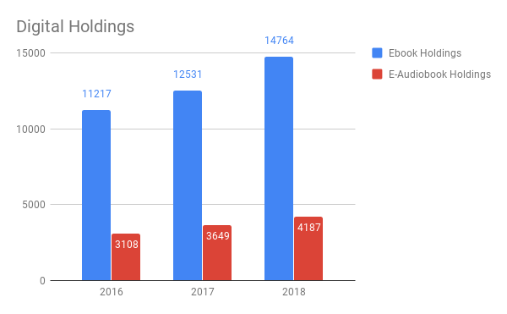
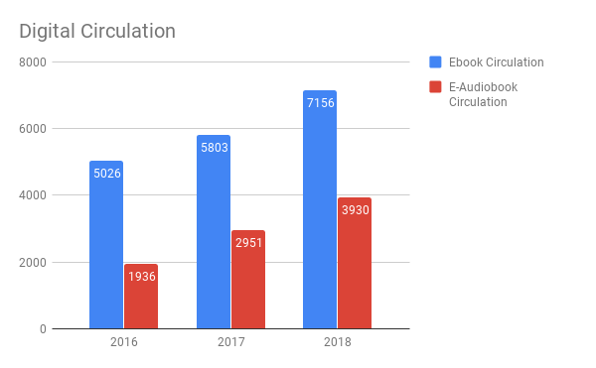
Digital literacy among Gloucester’s residents is varied. The library needs to provide training and support for those seeking digital literacy while offering a wide array of digital materials for those acquainted with the changing technological landscape. Based on the demographic data, the library must meet the needs of a young, increasing diverse community of digital natives, as well as an aging population with less native technical ability.
Analysis of Interlibrary borrowing and lending trends indicates that the library’s collections are not fulfilling demand. Collection development practices must become more responsive to meeting rapidly changing local demands.
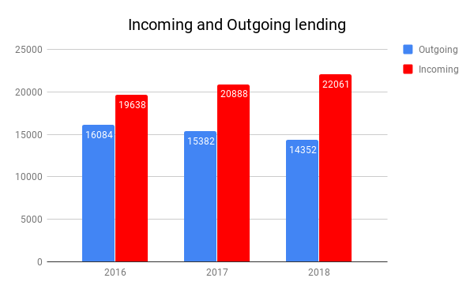
Increasing accessibility to library programs, services, and collections outside of the library building is also expanding the library’s reach. The library must become prepared to take all aspects of what it does and what it has to offer to the people wherever they are. This is especially important in Gloucester, as the library is not accessible to pedestrians outside of the Downtown neighborhood, parking is extremely limited and accessibility for those who rely on public transit is difficult.
The Community’s Meeting Place
Increasingly, people come to the library for much more than borrowing materials. Oftentimes, people come simply to be with one another. The days of “shushing librarians” is in the past and today the library can be one of the community’s best venues for socialization. This requires moveable, comfortable, reconfigurable furniture to provide places for quiet conversation, collaboration, learning and play.
The library should increasingly facilitate not only private but public conversations as well. For example, income inequality and housing shortages are two topics needing civil and productive conversation. The library’s resources provide a natural place for leadership in furthering these conversations.
Now more than ever, the library must play a role in Gloucester’s educational and social ecosystem. Opportunities for collaborations with other cultural and civic institutions provide ways to improve services for the entire community. For instance, the community provides a wealth of resources for making and creating. The library should help to break down the barriers and facilitate access to all of the community’s resources. Collaborations allow the library to extend its reach to new regions and populations within the city.
Co-working is a major societal trend and the library has always been and continues to be an appropriate space to engage in co-working endeavors. Gloucester is working to become a center of innovation in maritime manufacturing and technology. The library needs to provide both space and technical capacity to help organizations and individuals achieve this community goal.
Lifelong Literacy
Today, many types of literacy are required to empower individuals to achieve their full potential. These include digital, language, multicultural, and visual literacies. Support for each of these, within each age group, must become a central goal of any library. Developing literacy across diverse populations and all age groups is central to the library’s mission. Foundational to this mission is a staff trained in cultural literacy and devoted to the values of innovation and collaboration. A successful, holistic approach to literacy also rests on partnerships with local organizations within the community’s infrastructure. Digital literacy for all must be supported by training and mentoring as well as the creation of an online hub for digital literacy that is accessible to all. Multicultural literacy is promoted by identifying community partners and volunteers who will increase the multicultural reach of the library. By defining and supporting the entirety of literacies required for growth and success, the library becomes more responsive to the needs of the whole community. An empowered staff and a comprehensive plan toward this goal will yield a full range of community benefits and ensure the library’s role in this community for years to come.

