H.

Gloucester Lyceum

&

Sawyer Free Library

Building Program

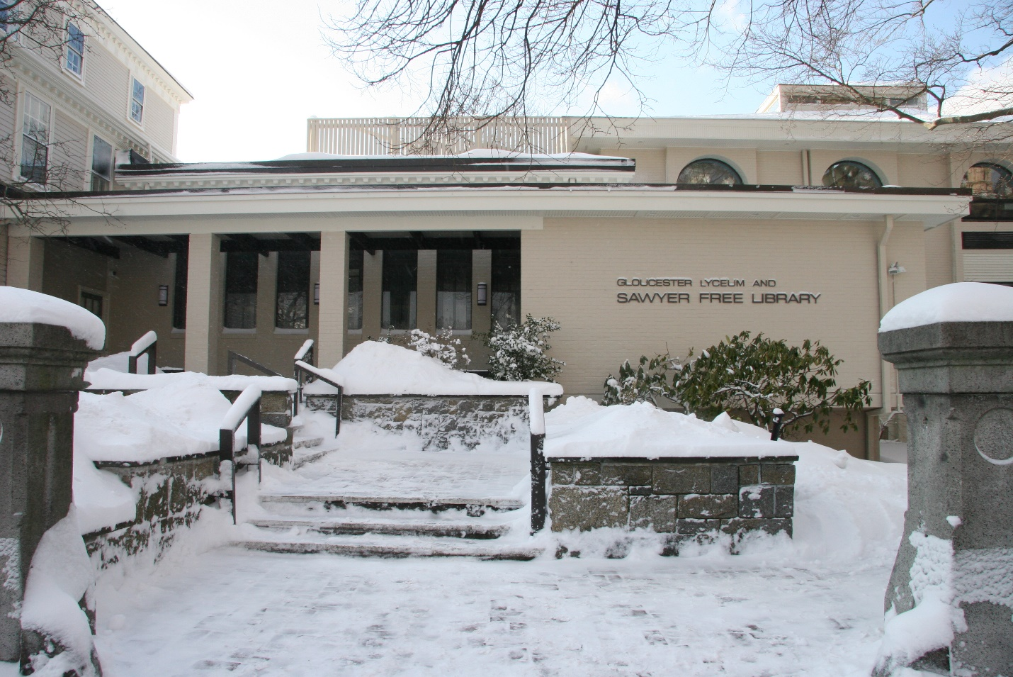

Deborah Kelsey, Library Director

Accepted by Rosemary Waltos, Library Building Specialist,

Massachusetts Board of Library Commissioners

Approved by the Board of Directors

February 24, 2016

Contributors:

Board of Directors:

Jerry Ackerman, Val Babson, Greg Bover, Barbara Braver, John Brennan, Joan Ciolino, Fred Cowan, Meredith Fine, William Fonvielle, Howard Frisch, Kecia German, Emily Glover, Scott Memhard, Daniel Ottenheimer, Windy Quinones, Mayor Carolyn Kirk – ex officio, and Mayor Sefatia Romeo Theken – ex officio

Community Needs Assessment Interviewees:

Tom Balf, Greg Bover, David Brooks, Dale Brown, Joseph Ciolino, Fred Cowan, Melissa Cox, Tom Daniel, Jim Destino, Melissa Dimond, Sal DiStefano, Cindy Donaldson, Rick Doucette, Caroline Enos, Chuck Everett, Bob Gillis, Ann-Margaret Ferrante, Ronda Faloon, Tim Faherty, Kathy Hamilos, Bill Jackson, Mary Kay, Julie LaFontaine, Mary Jane McGlennon, Paul McGeary, Avery McNiff, Soo Ae Ono, Martin Ray, Maggie Rosa, Catherine Ryan, Richard Safier, Lucy Sheehan, Tina Raimo, Jenny Rankin, Betty Roland, Sefatia Romeo Theken, Ben St. Cyr, Bruce Tarr, Bruce Tobey, Sue Todd, Lauren Trainer, Greg Verga, Rich Weissman, Dick Wilson and Stephen Winslow

Library Needs Assessment Committee:

Fran Aliberte, Lynn Chamber, Caroline Enos, Chuck Everett, Keri Eynon, Lauren Johnson, Susan Oleksiw, and Mary Weissblum

Staff:

Linda Bosselman, Diana Cummings, Helen Freeman, Kristen Jaques, Valerie Marino, Gail Mondello, Judy Oski, Lewis Parsons, Beth Pocock, John Prybot, Christy Rosso, Lisa Ryan, Matt Theken, Justine Vitale, and Cindi Williams

Strategic Planning Committee:

Jerry Ackerman, Barbara Braver, Carol Gray, Meredith Fine, William Fonvielle, and Frejya Sanger

**Table of Contents**

**Executive Summary – 4**

**History of the Library and the Community – 6**

**Community Analysis – 7**

**Library’s Mission, Values, and Service Roles – 13**

**Previous and Current Facility and Organizational Planning Efforts – 14**

**Pertinent Trends and Statistics, including Staffing and Public Use – 15**

**Description of the Existing Building – 18**

**Analysis of Current Collections and Services – 26**

**Special Circumstances for the Library and/or Community – 39**

**A Needs Assessment – 40**

**Space Needs Summary – 46**

**Site & Exterior Considerations – 48**

**Requirements – 50**

Accessibility

Acoustics

Aesthetics

Data & Telecommunications & Electrical

Ergonomics

Functional Areas

Furniture, Fixtures & Equipment

HVAC

Lighting & Electrical

Security

Signage

Sustainability

Windows

**Executive Summary**

Gloucester’s public library consists of an historically significant four-story wooden house with WPA murals on the first and second floors, built in 1764 and converted for library use in 1884,; the South Wing, a two-story brick addition built in 1913; and the Monell addition, a three-story brick-faced addition built in 1976. The gross square footage of the library buildings is about 23,500, but only 18,500 square feet are useful programmatically. The Library is situated in the heart of the City’s Downtown within an historical district and a cultural district.

Gloucester would like to renovate and expand its existing library facility or build a new 30,000 to 35,000 square foot library on another site in the City.

*Knight Soul of the Community 2010: Why People Love Where They Live and Why It Matters – A National Perspective, Knight Foundation* states there is a positive correlation between community attachment and local gross domestic product (GDP) growth. This is a key metric in assessing community success because local GDP growth not only measures a community’s economic success, but also its ability to grow and meet residents’ needs.

Community attachment is dependent on what matters most to residents:

* Social Offerings – places for people to meet each other and the feeling that people care about each other;
* Openness – welcoming to different types of people, including families with young children, minorities, and talented college graduates;
* Aesthetics – the physical beauty of the community including the availability of parks and green spaces; and
* Education – the quality of local colleges, universities, and K-12 public schools.

The City of Gloucester wants to attract new businesses, retain its college-educated young adults, and be home to families with young children. The public library should be integral to achieving these goals as a place supported by and accessible to all citizens. The library should convey the impression that the community cares about all of its residents by providing a place with enclosed spaces for inspiration, creation, and contemplation and social spaces for learning, meeting, and performance.

The public library should be an essential educational facility to support learning throughout the life of each resident as the community’s “learning commons.” It is the primary institution to support parents as their children’s first teachers. Everyone, especially young adults, needs a public library with access to up-to-date and emerging technologies, online learning opportunities, and a “smart” enabled environment to realize their potential and thrive.

There is and will continue to be a strong need for well-curated print collections even though use of the library is changing as traditional collections share increasingly the library’s platform with electronic, remotely accessible collections.

Gloucester’s diverse population, with equally diverse interests, has led to an unusually large number of social, artistic, literary, and other types of organizations whose goals are often parallel and even overlap. The library encourages, supports, and fosters community collaborations and partnerships. The library should to be a “culture house” for the community.

Gloucester loves the Sawyer Free Library. At least they love the idea of their library as a vital place for people to innovate, experience, participate, and be empowered. They want it to be a place for the community to gather for discovery, reflection, and learning. They describe the public library as a treasure, a centerpiece, a wonderful resource, important, and serving a unique role.

However, it is clear by every measure that the current library building is inadequate to meet the community’s needs. It is unwelcoming, uncomfortable, unsafe, and out of compliance by today’s standards for accessibility and fire prevention from the front steps and throughout the entire interior.

Gloucester needs a new or renovated library that embodies the community’s aspirations to be a hub of innovation, a place where arts and culture thrive, where its history is preserved and cherished, and where all are and feel welcome.

**History of the Library and the Community**

Originally called “le Beau Port” (Beautiful Port) by Samuel Champlain who visited in 1605-06, Gloucester was colonized by an expedition of men from Dorchester, in the county of Dorset, England, chartered by James I in 1623. Around the same time, a group of Pilgrims from the Plymouth Bay Colony also sailed to Gloucester and built the first racks for drying fish. It was one of the first English settlements in what would become the Massachusetts Bay Colony. The town of Gloucester was incorporated in 1642. It grew steadily and prospered, becoming a city in 1873 with a population of 16,000.

The antecedent of the current library dates back to February 15, 1830 when nearly 100 Gloucester residents met and formed the Gloucester Lyceum. The purpose of the organization was to bring community members together to participate in lectures and debates that fostered ideas, information and learning. The lectures had both “literary and philosophical merit.” Samuel Sawyer became an active member in the 1840s. He recognized that in a true democracy, individual success means success for the community as a whole, and the key to individual achievement is education. His values led to the formation of a library.

Mr. Sawyer’s involvement and financial support enabled the continuing growth of the library. He purchased a prominent residence on the corner of Dale Avenue and Middle Street, the Saunders House built in 1764, and donated the four-story wooden building along with an endowment with the purpose of providing free library services to Gloucester. In 1884, The Gloucester Lyceum & Sawyer Free Library was dedicated in the same building it occupies today with the motto “Books are lighthouses on the sea of time.” At the dedication, Mr. Sawyer said “It has always been a prominent motive or object of my life to do something to promote the best interest of the young, for in them lie the germ, the roots and fibres of civilization. Books are the food of the mind; from the earliest years of childhood books are sought to feed the intellect, and so from school to college; later on they are a course of recreation to the idler, the tools of the student, the scholar and the man of letters.”

**Community Analysis**

Gloucester is a city located in northeastern Massachusetts, thirty-one miles from Boston, in the North Shore region of Essex County, on the Cape Ann peninsula. The total area of Gloucester is forty-two square miles with a total land area of twenty-six square miles of varied terrain, coastal natural resources and spectacular views. A large part of the city is an island, shared with the Town of Rockport, separated from the mainland and remainder of the city by the Annisquam River, an estuary, and Ipswich Bay. The island side is reconnected to the mainland by two automobile bridges: the beautiful 20th century A. Piatt Andrew Bridge, and the Blynman Drawbridge, affectionately called “The Cut,” and a railroad bridge. This rocky cape is defined by the sea around it, with more than thirty-five miles of coastline along the Atlantic Ocean, harbors and coves, and the Annisquam River.

Nearly half of the land area of the city comprises the West Gloucester and Magnolia neighborhoods, which are less densely populated than the city as a whole. Much of this land is underdeveloped and maintains its natural qualities – from beach dunes and marsh to inland wetlands to massive ledge outcropping. A large part of it is set aside for watershed protection, recreation and preservation purposes.

The busy downtown Gloucester, adjacent to Gloucester Harbor, reflects the commercial history of the city from late Federal brick and solid Victorian building, with varied uses, to working wharves, and a lumber yard and the Coast Guard Station at the water’s edge. Residents and visitors like to be in the downtown, doing business or just walking. Traffic is sometimes heavy and parking is often tight. It is truly a mixed-use district, with retail and commercial services, the Post Office and City Hall, Library, social institutions, and a new generation of residents and businesses. The area requires continued attention and investment. Much of the downtown remains underused; some public and private properties are in relatively poor condition. The future offers continued opportunity for upgrading and face-lifting.

The population is socioeconomically diverse with working-class residents and first-generation immigrants as well as old wealthy families and newer summer visitors. Summer people displace off-season renters and homeowners who migrate to rent them their residences. People are attracted by the beautiful harbor, the picturesque fishing fleet, seaside restaurants, colorful festivals, the Cape Ann Museum and Gloucester Stage Theatre Company, and large green spaces and beaches.

The city is home to one of the oldest continuously operating art colonies in the United States, Rocky Neck. Gloucester is a rare community with two Cultural Districts, Harbortown and Rocky Neck, newly designated by the Massachusetts Cultural Council. The city received a Commonwealth Award for Creative Community for providing leadership, funding and infrastructure to the places where art and culture are presented and where artists live and work.

The city has had a tradition of innovation since it was first settled. Early industry included subsistence farming and logging. Fishing was limited to close-to-shore. The town became a shipbuilding center with the first schooner reputedly having been built here in 1713, followed by the building of Georges Bank and Gloucester dories. The community became an important fishing port. With the advent of steam, the eastern-rig dragger was designed, followed by the western-rig fishing boats. In the 1800s Gloucester developed a thriving granite industry. In the 1900s Clarence Birdseye developed flash-freezing technology and John Hays Hammond, Jr. invented radio control and held more than 400 patents.

Today, Applied Materials is a leader in ion implant systems and the Gloucester Marine Genomics Institute launched the first DNA sequencing study on the cod genome. Innovation House, a meeting place for entrepreneurs who want to network and collaborate with others in tech space, or get away from their home offices to recharge in a peaceful rural setting, was started in 2014. The new Gloucester Life Sciences Academy will be offering an intensive laboratory training program funded by the state to prepare graduates for technician positions in the local biotechnology industries.

In the future, Gloucester could emerge as an innovation and marine biotechnology hub. At present the city needs a more diverse economy. Roughly a third of the jobs are tied to fishing and marine-related sectors.

A need for modern, business-friendly accommodations with Wi-Fi and conference rooms will be met with the new 96 room Beauport Hotel, opening spring 2016.

The city’s infrastructure is aging. Because most of Gloucester is on top of rocky ledge, improvements to the infrastructure are costly. There has been and needs to be significant capital investment to upgrade and improve the water supply, public water and sewer systems, sewage treatment plants, and high-speed internet services. Since 2000 considerable public and private funds have been expended to separate storm water runoff from downtown sewer lines, install sewer primarily in North Gloucester, and via the implementation of our Wastewater Management Plan, upgrade onsite septic systems to Title 5 to greatly abate coastal pollution. Simultaneously, new water lines have been laid wherever possible to eliminate “summer water” lines and to replace fragile occluded deep water lines. Gloucester has vast fresh water resources. The water treatment and distribution system has undergone extensive renovation. Water Emergencies are declared in high volume use times because of distribution pressure concerns that affect fire suppression capability in the outlying areas. Contracts were negotiated with internet providers to have the City rewired for high-speed internet access.

**Education** (*Massachusetts Department of Education*)

The Gloucester School district has 2,963 students enrolled. The census has declined from 4,100 students in 2000 to 2,600 in 2015, and is projected to decline to less than 2,000 students by 2035.

Gloucester has five elementary schools for 1,452 students without the services of a school librarian. Beeman Memorial, Veterans Memorial, and East Gloucester are Title I schools where at least 40% of the children are from low-income families. Parents in Gloucester may use School Choice to send their children to schools in other districts. More than 30% of the incoming kindergartners in neighboring Rockport are Gloucester residents.

The O’Maley Innovation Middle School has 629 students. After more than a decade of no school librarian in the middle school, a process has begun to create and staff a learning commons for 2015-2016 school year.

The Gloucester High School has 882 students. The school’s librarian oversees the learning commons, teaches bibliographic instruction and coordinates Gloucester U, an after-school program that offers more learning opportunities with community partners.

A social services organization called Action offers alternative education programs and support services to teens and young adults experiencing barriers to learning in the public school system through Compass Youth Program with community partners, Cape Ann Art Haven, Maritime Gloucester and Santander Bank.

Action’s Job Training and Education program offers classes, training, job-readiness and support to help unemployed and underemployed adults gain new skills and better jobs. Adult education includes reading, writing, math, and work skills; preparation to take the High School Equivalency Test; and supportive services. Healthcare career training includes home health aide and nurse aide training programs; and life skills and job readiness services. Job readiness includes working with the Gloucester branch of the North Shore Career Center; running a career transitions class to help with basic skills; and providing individual assistance on the development of career goals, resume building, interview skills, and address barriers to employment. In the next three years, there are plans to offer multiple classes in CPR, ServSafe, money management, and computer skills. Other skill development activities being considered are culinary training, an EMT course, childcare and babysitter related courses, health/nutrition/exercise education, parenting skills education, a program for those raising grandchildren, and life skills/soft skills for high school students and recent graduates.

Endicott College began offering classes in downtown Gloucester in 2012. The College hopes to have a permanent facility in the City.

High school drop-out rate: 5.2% (Massachusetts 5.6%)

High school graduation rate: 89.5% (Massachusetts 86.1%)

High school graduates attending colleges and universities: 63.4% (Massachusetts 76.6%)

High school graduate or higher (% of persons age 25+): 89% (Massachusetts 89.4%)

Bachelor’s degree or higher (% of persons age 25+): 34% (Massachusetts 39.4%)

An unusually high number aged 45 to 65 have advanced or professional degrees.

**Employment and Income**

Technology is gaining as fishing-related employment, the city’s historic economic base, shows few signs of recovery after decades of decline. Manufacturing, led by technology and including food processing, employs about a quarter of the labor force and accounts for about half the city’s total household income. The balance of local jobs is mostly in health care, retailing, government, or food and beverage and tourism-related businesses, with tourism gaining. Many of these are low-paying, part-time or seasonal. The downtown area supports almost half of the largest employers – Gorton’s, Shaw’s Markets, Gloucester High School, Strong Leather, Action and the YMCA contribute substantially to the employment base.

About a quarter of the labor force commutes more than 30 minutes each way to work, twice the number of a generation ago. There has been an influx of sophisticated businesses and individuals working from home that rely on high-speed internet access.

**Incomes**

Although there are highly visible pockets of wealth, Gloucester incomes are well behind much of the state. The gap between rich and poor is widening. Overall income lags state averages by about 10 percent and income growth by about 20 percent. Incomes adjusted for inflation fell between 2000 and 2010 by 20 to 40 percent in nearly all brackets below $50,000 a year, but about doubled in brackets over $100,000 a year. Even well-off households, those reporting $100,000 a year or more, averaged about 20 percent less in 2010 than the same quintile statewide. Unemployment is persistent, currently at about 7% after topping 12% between 2008 and 2011.

Labor force in June 2015: 15,796

Unemployment in June 2015: 5.9% - 925 (Massachusetts 4.9%)

Median household income: $62,059 (Massachusetts $66,866)

Median per capita income: $36,919 (Massachusetts $35,763)

Persons below poverty: 8.3% (Massachusetts 11.4%)

**Housing** (*2010-2012 Census estimates*)

Gloucester’s desirable qualities are linked to variable density, from the clustered buildings of Downtown and village centers to the concentrations of homes in neighborhoods to rural, low-density areas.

The Downtown is densely developed and densely populated. With only five percent of the city’s land area, it is home to nearly twenty-two percent of the population, in a combination of single family and multi-family housing units.

Housing units: 13,813

Housing units in multi-unit structures: 43.1

Owner-occupied: 7,496

Renter-occupied: 4,603

Vacant: 1,714

Homeownership rate: 65.3% (Massachusetts 62.7%)

Medium value of owner-occupied housing: $374,900 (Massachusetts $330,100)

**Population** (*Donahue Institute, University of Massachusetts*)

Gloucester’s population is steadily shrinking and aging. The school-age population is diminishing. Persons over 65 now account for more than one-sixth the total, well above the state average. The median age now is about 42, or two years older than in 2000, apparently driven in part by retirees or empty-nesters relocating to a coastal community.

Gloucester’s population reflects the changes in the state’s population more dramatically.

Gloucester’s population will decrease from an estimated 29,238 in 2015 to 24,634 in 2035. The only segment of the population to increase will be the elderly, those who are 70 years of age or older.

Of individuals 65 and older, the state’s population will increase from 14% to 21% versus Gloucester’s population from 17.71% to 36.94% between 2010 and 2030. Conversely between the same time period, of individuals 19 years old or younger, the state’s population will fall from 25% to 22% versus Gloucester’s population from 20.66% to 14.66%.

Gloucester is projected to lose 15.76% of its population over twenty years, for a loss 4,608 residents, a trend that is opposite the trend for the whole Northeast region of Massachusetts.

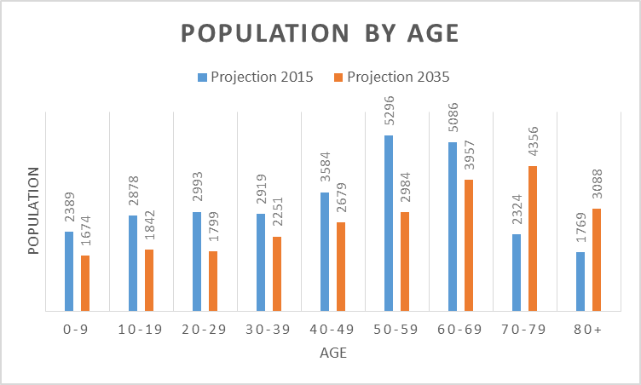

Race/Ethnicity

Currently, about 8% of the population is foreign-born, more than half from Italy, Brazil and Hispanic America. 11% percent speaks a second language at home, led by Italian/Sicilian and Portuguese. The racial and ethnic diversity will remain very similar, primarily white. The exception will be the Hispanic or Latino population will increase to about 1,232 or 5%.

White: 28,126

African American: 516

Asian: 310

American Indian or Alaska Native: 219

Native Hawaiian or Pacific Islander: 0

Two or more races: 473

Hispanic or Latino: 826

Not Hispanic or Latino: 28,111

**Transportation and Access**

Gloucester is the northeastern terminus of Route 128, which forms the inner belt around Boston. The city is also served by Routes 127 and 133. Commuter rail service to North Station, Boston, is available from the downtown and West Gloucester. The Cape Ann Transportation Authority provides fixed route service within the city, between Gloucester and Rockport and Dial-A-Ride service for the elderly and disabled. Lahey Health and the Council on Aging coordinate volunteers to provide transportation to medical appointments. Ambulance service is provided by the Fire Department and Beauport Ambulance Services, Inc. There are several taxi-livery services. Enterprise Car Rental has an office in the city.

**Library’s Mission, Values, and Service Roles**

**Vision:**

The vision of the Gloucester Lyceum and Sawyer Free Library is to be fully relevant as the needs of Gloucester’s public evolve.

**Mission:**

The mission of the Gloucester Lyceum and Sawyer Free Library is to inspire lifelong learning, foster intellectual curiosity, and strengthen our community.

**Values:**

The values of the Gloucester Lyceum and Sawyer Free Library are:

* Available freely to all,
* The open exchange of ideas,
* Intergenerational connections,
* Relationships and collaborations with community partners,
* Environments that nurture creative thinking and problem solving,
* Basic literacy, education, intellectual curiosity, and lifelong learning, and
* The history and culture of Gloucester,

**Service Roles:**

The core role of the library is grounded in the ancient role of libraries as places of community and collaboration. For Gloucester this translates into a third place, not home, or school/work, for collaborative learning and community interaction. The public library is no longer a warehouse for collections or a central point of information service, although the library’s hybrid operational environment of both analog and digital services and collections will continue to fulfill both these roles. *Susan Montgomery and Jonathan Miller, “The Third Place: the library as collaborative and community space in a time of fiscal restraint” 2001*

* Providing inviting and attractive physical and virtual spaces;
* Encouraging connections among people of all ages;
* Acquiring, maintaining and providing access to local history collections;
* Serving the whole community including governmental entities, nonprofits, businesses, and civic groups as well as marginalized and underserved people;
* Providing free access to information, literature, and ideas; and
* Providing access to current technologies and supporting technological literacy.

**Previous and Current Facility and Organizational Planning Efforts**

Twice the library facility has been expanded to meet the growing needs of Gloucester. In 1913 the library corporation funded the construction of a brick-faced wing that allowed the library’s books to be housed on a two-story metal shelving structure built to hold the weight of the collection. In 1976 the library celebrated the opening of a three-story, brick-faced addition after several acts of the state legislature, with city funds, grants, and the library corporation.

Through the efforts of the library community, the city was awarded a $4 million grant for public library renovation, expansion and modernization in 2005. However, the community did not vote to approve the referendum on a debt exclusion of $7 million in 2007. Consequently, the city could not accept the state funds.

*Proposal for an Archives Research Center for the City of Gloucester, Massachusetts, Platt Anderson Freeman Associated Architects, 1995*

To preserve the City’s extensive collections of historical records and enhance their accessibility. The study determined that it was feasible to construct a storage facility in the Sawyer Free Library that would meet recognized standards for archival storage with an adjacent archive study area. The Archive Committee identified the solution described as a best available alternative. The proposed solution provides a usable facility that is adequate for storage and available on a part-time basis as an archive research center and anticipates that future expansion of the library may provide, among other things, a new meeting room to take the place of the Friend Room, thereby making it available full time for an expanded research center.

*Feasibility Study for the Renovation and Expansion of the Gloucester Lyceum and Sawyer Free Library, Gloucester, Massachusetts, Finegold Alexander and Associates Inc., March 2001*

*Report of a Preservation Survey, Millie O’Connell, Preservation Consultant to Northeast Document Conservation Center, February 2003.*

*Building Condition Survey and Capital Reserve Plan, Andrea M. Gilmore, Building Conservation Associates, Inc., March 2003*

*Americans with Disabilities Act – ADA Transition Plan Update/Site Access Survey for the Gloucester Lyceum & Sawyer Free Library, John C. Miller, Community Advocacy Liaison, Northeast Independent Living Program, Inc., ADA Access Group, May 2006*

*Building Envelope Condition Survey, Noblin & Associates, LLC, October 2009*

**Pertinent Trends and Statistics, including Staffing and Public Use**

Direct circulation of library materials has increased over the last two years, while use of the library building continues to decline. Many potential users are put off by the indigent population that uses the library building and its grounds. Others find the physical environment too uncomfortable due to scary restrooms, poor air quality, and lack of modern heating and cooling.

The Sawyer Free Library is the only one of the four Cape Ann libraries to still provide professional reference services. The library will become the go-to place and portal for regional information and history.

The current staff is becoming more professional in terms of their education, skills, and capacity. Additional well-trained professional staff dedicated to public service in a world of rapid change are needed to provide modern library services. However, competition for municipal financial support is significant. Therefore, adding staff is unlikely. Future hiring decisions will be based on the need for staff with high levels of special skills in technology, communications, graphic design, web portal management, service design, archives, and the community’s languages.

As part of the library’s most recent strategic planning process the following significant trends were identified:

Historical Fragmentation among Community Institutions: Gloucester’s diverse population, with equally diverse interests, has led to an unusually large number of social, artistic, literary, and other organizations whose goals are often parallel and even overlap. As a place supported by and accessible to all citizens, the library can help foster collaborations and partnerships.

Historical Opportunity in Programming: The number of potential adult learners in the community is growing and economic change is creating new demands for new knowledge and training. The library, which already hosts classes in English as a second language, is a clear candidate to fill this learning void.

Changing Space Needs: The current library was built well before the advent of the Internet age. Recent investigation has revealed not only potential for reducing or consolidating print collections in favor of digitally accessed information, but a large amount of space available for conversion to other uses, including meeting, classroom, and activity spaces.

The Sawyer Free Library staff identified five trend areas in Gloucester: demographic, economic/business climate, educational, lifestyle/social value, and technological.

Demographic:

* Move toward urbanization
* Greater generational differences
* Growth in indigent population
* Continued substance abuse & crime
* Growth in senior population
* Decrease in customer service; increase in self-service
* Decline in youth population
* Increase in minority populations
* Increase in well-educated professionals
* Increase in people with physical limitations

Economic/Business Climate

* Shorter economic cycles
* Decline in the fishing industry
* Growth of visitor-based economy
* Gap between skills and employers’ needs
* Demand for innovation
* Decline in local industry
* More residential tax base
* Flat funding for municipal services

Educational:

* Rise in online learning
* Prioritization of STEM/STEAM
* Preference for participatory and self-directed learning
* Education falling behind workforce needs
* Escalating cost of education
* Women higher educational achievement
* Increase diagnosis of learning disorders

Lifestyle/Social Value

* Growth in obesity
* Decrease in ownership
* Interest in “Do It Yourself”
* More people working from home
* Preference for all things local
* Desire for vibrant, walkable neighborhoods
* Value the natural world
* Decreasing privacy, increasing surveillance
* Willingness to spend discretionary funds on experiences rather than material goods
* Difference between social and leisure time
* Less willing to wait

Technological:

* Explosive growth in use of mobile devices
* Growth in cloud computing
* Increase in cyber attacks
* Expanded access to platforms and applications
* Iniquitousness of social media
* Unbundling services
* Digital haves and have nots
* Bring your own
* Availability of Amazon and Netflix
* Change in publishing
* Smart devices as portals for targeted marketing
* Less privacy
* Device standardization or a universal device

**Description of the Existing Building**

**Summary**

Gloucester’s public library consists of an historically significant four-story wooden house with WPA murals on the first and second floors, built in 1764 and converted for library use in 1884. A two-story brick addition was built in 1913, and a three-story brick-faced addition was built in 1976. The library is situated in the heart of the City’s Downtown within an Historical District and a Cultural District.

It has been nearly forty years since the most-recent addition was built and the interior looks every day of its age.

Positives

* Thirty-five dedicated parking spaces, of which two are for handicapped use.
* Attractive grounds with permanent outdoor seating.
* Outdoor amphitheater.
* Potentially light, airy, open feeling in the 1976 addition, especially where the windows are not obstructed.
* The public frequently describes the library as welcoming, peaceful, inviting, and comfortable. (These words reflect what their public library should be, rather than what it is.)
* Separate, large meeting room with adequate technological infrastructure.
* Separate, self-contained children’s space.
* Accessible entrances to the lower level.
* Centrally located in Downtown Gloucester, the heart of the city, including the core civic center
* Convenient
* Walkable for downtown residents
* Public restrooms

Negatives

* Lack of balance among an opposing range of functions and needs, especially in terms of acoustics, i.e. quiet versus noise. There are no reading and study spaces, collaborative workspaces, spaces for groups, learning and teaching spaces, technology-free zones
* Lack of climate-controlled archives and special collection spaces.
* Lack of self-contained, safe teen-specific space. The teen zone is located in an area where the expectation is for quiet.
* Children-specific space does not contain family restrooms, an area for stroller parking, or story time and maker areas.
* Security and safety are inadequate especially on the lower level due to poor design decisions. Restrooms are access-restricted due to the presence of individuals who are known to behave in socially inappropriate and unsafe ways.
* Lack of full accessibility throughout the facility from the main entrance, elevator, restrooms, and stacks. Not all exterior exits have panic bars. Some of the doors have correct handle hardware. The restrooms for children have undersized doors and inadequate square footage. There are several areas on all levels where the stacks prevent wheelchair access. In general, the shelving practices create challenges as materials are shelved at floor level and above fifty-four inches.
* Inadequate lighting throughout the building, especially in 1913 wing, and parts of the Saunders House. There is no task lighting used in 1976 addition.
* Poor climate control throughout the building creating a library that is excessively hot, muggy, and oppressive in the summer in the areas without air conditioning, and too cold in many places in the winter. Vulnerable archival materials are housed in an area with the most variable and extreme environment.
* Antiquated and broken HVAC systems. Saunders House and 1913 wing are heated primarily by steam from an oil-fueled furnace boiler with one zone. There are electric wall heaters in the 1913 wing stacks that have ignited wooden stepstools. The 1976 addition’s primary heat source was one gas-fueled rooftop unit condemned after filling the building with CO. The secondary heat sources are electric under-window units. The lower level is heated with hot air blowers from the boiler.
* Poor adjacencies throughout with no staff offices near or within their department areas. The library administration is located in inaccessible space. The archival and local history materials are housed in multiple areas on different levels. The adult nonfiction print collection is housed on different levels. There are no restrooms on two of the three levels the public use.
* Inadequate data and telecommunications. The facility lacks sufficient technological infrastructure for high-speed Wi-Fi, wired internet, VOIP telephone system.
* Inadequate electrical outlets.
* Furnishings are tired and do not meet fire code.

**Description of the Existing Building**

The three connected buildings provide different perspectives and views that are pleasing and stand as one bookend to the Downtown civic center of the city, City Hall, with the Cape Ann Museum the other bookend. Donald Monell, a local architect, designed the additions of both the Cape Ann Museum in 1967 and 1976 respectively, with similar basic lines and design. The library is situated within an Historic District and a Cultural District designated by the State of Massachusetts.

The gross square footage of the library buildings is about 23,500, with 18,500 square feet useful programmatically. The 1976 addition contains most of the useable space with large, attractive windows letting in natural light and air on all three levels. There is Wi-Fi throughout the facility.

The lower level has two accessible exterior entrances: one off of a thirty-five space parking lot and the other on the side facing Central Grammar Apartments. Access to the main and upper levels requires the use of a small elevator or one of two fire exit stairs. Lower level has a self-contained children’s space, a large community meeting room with artificial light only, some storage, full kitchen and a secure space for technology infrastructure and equipment storage, and four small restrooms with restricted access. Keys for the children’s restrooms access are available in the children’s room through staff mediation. Keys for the adults’ restrooms access are available in the circulation department on the main level of the library. Users are expected to obtain a key and return it, which results in two trips between levels.

The main exterior entrance on Dale Avenue to the main level is forbidding and accessible by stairs only. The main level has a mixture of open floor plan with soft seating and task seating at tables. There is an art gallery, display cases, a new materials browsing area, the library Friends’ ongoing book sale, open holds, promotional displays, community bulletin board, photocopier, and the library’s adult collections in world languages, literacy, music, fiction, recorded books, and serials. There is an overly large main circulation services desk with self-check stations and staff workstations with one telephone. The stacks are very high with oak end panels blocking most of the windows. In the near term, the teen space will be relocated to this level.

The upper/mezzanine level is open to the main level in the center with a metal and oak surround railing. The upper level has teen services, reference and research services, study carrels, wired computer workstations and print-release station, microforms and readers, and print collections in local history, teen fiction and nonfiction, reference, and most of the adult non-fiction print collection, and all of the teen fiction and nonfiction collections. The stacks are very high with oak end panels blocking most of the windows. In the near term, this level will house all of the adult and teen nonfiction books and all archival and adult non-circulating collections.

The first level of the 1913 wing connects the Saunders House to the 1976 addition. The space has narrow, fixed stacks, opaque windows, dim lighting and climate that is widely variable in terms of temperature and humidity. This area houses the entire video and game collections and the rest of the archival and some of the adult nonfiction collection. In the near term, the staff plan to move the Friends’ ongoing book sale to this area. The second level is accessed by climbing narrow stairs only. Currently, the second level houses some of the adult nonfiction collection. In the near term, the staff plan to use the space for storage only.

The Saunders House front and rear exterior entrances are restricted and accessible by stairs only. Two of the main floor rooms are available to the public for small meetings and tutoring sessions. There are two small restrooms restricted to staff use. One room is functioning as secure space for technical services. The rest of the space is open for tutor sessions, shipping and receiving, storage, and mail distribution.

The second floor of the Saunders House is dedicated to the staff with one room a shared office for the library director and assistant director, a large double room for staff/director meetings, staff workstations, files and supplies, and one room for a staff lounge. There are very wide hallways in which more staff workstations and meeting space are located. There is a small restroom.

There are historically significant WPA murals on the first and second floors. The murals were restored and repainted with different images in 1954 and washed and retouched in 1976. At that time, the restorer painted murals in a similar style in the large double room on the second floor.

The chimneys in the Saunders House are stable, but the wooden house is shrinking naturally and settling over time. The second floor was stabilized in the last few months with new footings, posts, and beams after a severed main weight-bearing beam was discovered.

The third floor of the Saunders House has been used for storing local history materials, art work, financial records, and outdated equipment and furnishings for decades. The staff is working on clearing out the space.

There are interconnected basements via stairs under the Saunders House and 1913 wing. There is significant water seepage. These spaces have been used for storing periodical back file, discards, financial records, Friends donation sorting, and disc cleaning. The connecting doors are not fire-proof and there are no emergency exits. The staff is working on clearing out as much of the space as possible.

Most of the building’s systems: furnace, electrical panels and data hubs and switches are located in the Saunders House and 1913 wing basements and the lower level of the 1976 addition. There is one rooftop air handling unit on the 1913 wing for the 1976 addition main and upper levels. There are window air conditioning units cooling the children’s area and about half of the Saunders House. There are small windows at the apex of the 1976 addition’s roof that can be opened to vent the building of heat during the warmest months. Air circulation is aided by large, noisy fans on the main and upper levels of the addition. There is a water sprinkler protection system for the entire facility.

Lower Level with the two accessible entrances and the only public restrooms.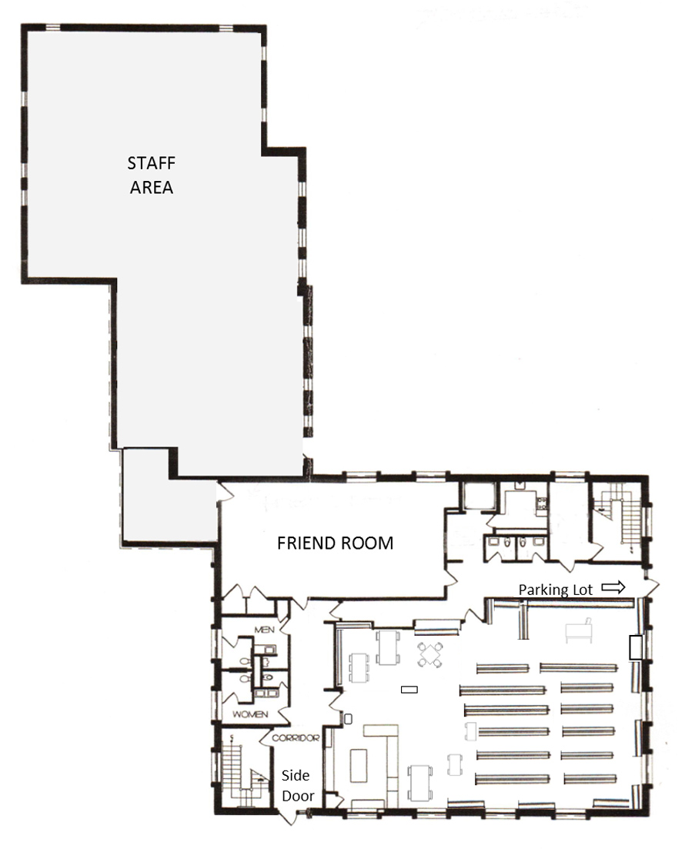

Main Level with Saunders House, 1913 South Wing, and 1976 Monell Addition from top to bottom with the non-accessible main entrance on the left in the middle.

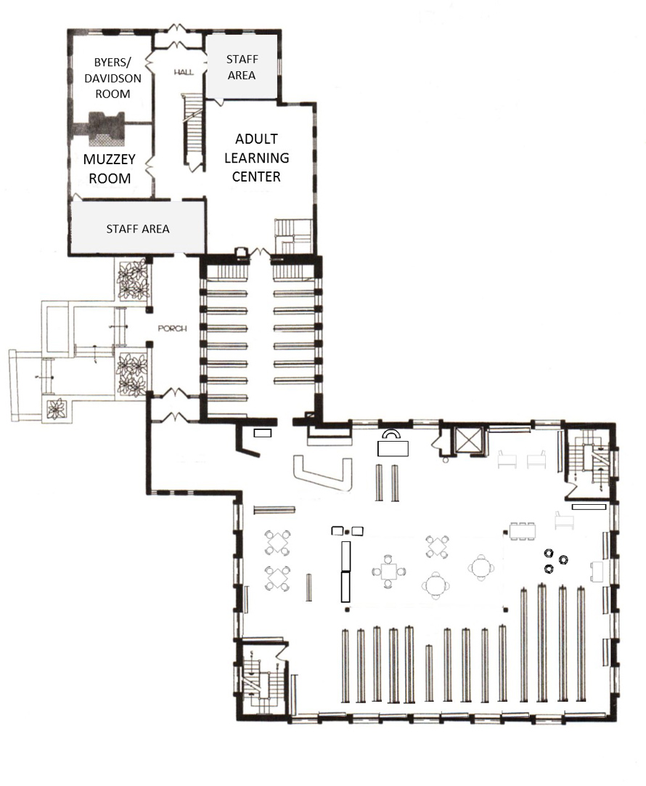

Upper Level

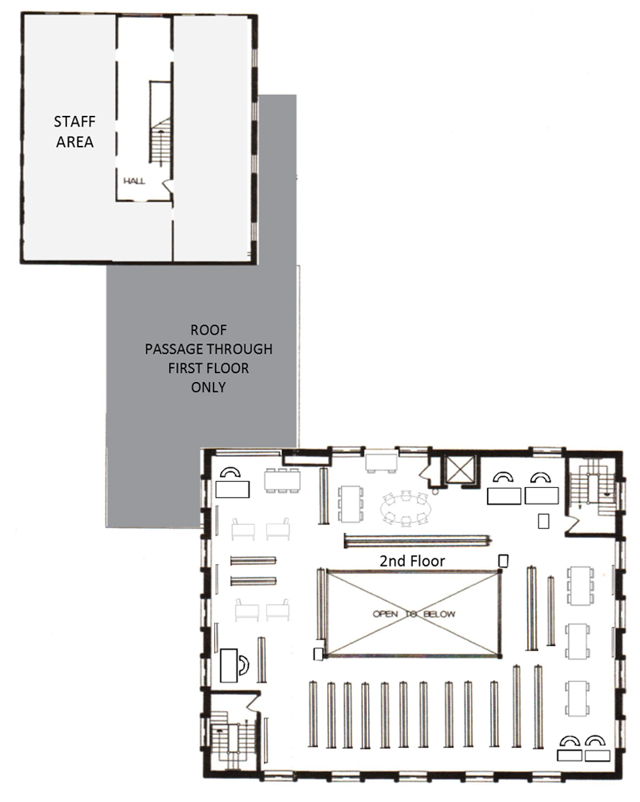

**Impressions of the Library Building** from interviewees and survey respondents:

* Tired
* Dark
* Unsafe
* Hot in summer
* Uninviting, not welcoming
* ADA non-compliant
* Not up-to-date technologically; doesn’t reflect the need for electronics
* Teen area not enclosed
* Children’s too small
* Makes the Senior Center look hip
* Warehouse for books
* Doesn’t have the space needed for teens
* A little shabby
* Challenged to feel welcome
* No modern HVAC system
* Disgusting
* Poor air quality; Smelly
* Scary
* Cannot see into the library from the entrance
* Hate having the only public restrooms outside the children’s room
* Poor sightlines

**Analysis of current collections and services**

**Summary**

The use of collections in physical formats is decreasing while use of electronic formats is increasing. Remote use is increasing. Gloucester is a net borrower through the interlibrary loan program. The library will be undergoing a comprehensive weeding program over the next two years to reduce the number of physical items, increase the currency, and curate the entire collection. Overall goal is to provide excellent, professionally curated collections in print and electronic formats.

Ideally staff would be increased to provide library services through outreach to underserved populations, preschool and elementary school students and their parents, and the five neighborhoods; to forge and maintain effective community partnerships and collaborations; to develop and provide access to local history and archival collections; to perform ongoing technology planning, implementation, maintenance, and training; and to develop and provide access to the virtual library.

*Wisconsin Public Library Standards, Fifth Edition, Wisconsin Department of Public Instruction, 2010*

Quantitative Standards by Service Population of 25,000 to 49,999

Gloucester’s population 29,393

+ the additional population served 3,148

= a service population of 32,541.

FTE Staff as of November 2015

Gloucester 16

Administration 3

Technical Services 1

Visitor and Member Services 4

Information and Research Services 2

Teen Services 1

Children’s Services 4

Pages 1 (3 part-time positions 10 hour per week)

Basic/Moderate 16.27 Enhanced 19.52 Excellent 22.78

Volumes Held (Print) as of June 2015

Gloucester Actual 109,381

Basic 91,112 Excellent 133,481

Gloucester E-Books 10,012

Periodical Titles Received as of July 2015

Gloucester Actual 132

Gloucester Downloadable Digital 53 titles

Basic 176 Excellent 335

Audio Recordings Held as of June 2015

Gloucester Actual Physical Formats 7,141

Gloucester Downloadable Digital 3,108

Basic 6,183 Excellent 11,389

Video Recordings Held as of June 2015

Gloucester 4,526

Gloucester Downloadable Digital Video 0

Basic 6,833 Excellent 13,993

Public Use Internet Computers

Gloucester 28

Basic 17 Moderate 21 Enhanced 26 Excellent 45

Hours Open

Gloucester 59

Basic 59 Moderate 63 Enhanced 67 Excellent 69

Materials Expenditures

Gloucester $125,894

Basic $107,382 Excellent $234,946

Collection Size (Print, Audio & Video)

Gloucester Physical Format 121,305

Gloucester Downloadable 13,120

Basic 107,383 Excellent 159,446

**Current Library Capacities**

|  |  |
| --- | --- |
| Print Volumes – Adult | 70,525 |
| Print Volumes – Children | 31,689 |
| Print Volumes – Teen | 7,167 |
|  |  |
| Periodical Subscriptions - Adult | 226 |
| Periodical Subscriptions – Children | 21 |
| Periodical Subscriptions - Teen | 10 |
|  |  |
| Audio Recordings - Adult | 6,423 |
| Audio Recordings – Children | 718 |
| Audio Recordings - Teen | 0 |
| Video Recordings - Adult | 3,013 |
| Video Recordings – Children | 1,513 |
| Video Recordings - Teen | 0 |
|  |  |
| Fixed Computer Stations – Adult | 12 |
| Fixed Computer Stations – Children | 7 |
| Fixed Computer Stations – Teen | 0 |
|  |  |
| Parking Spaces – Staff | 0 |
| Parking Spaces – Library Patrons | 33 |
| Parking Spaces - Handicapped | 2 |
|  |  |
| Meeting Rooms Seats (Main) | 75 |
| Other Room Seats | 37 |
| Children’s Program Room Seats | N/A |
|  |  |
| Adult Space Seats | 73 |
| Children’s Room Seats | 41 |
| Teen Space Seats | 25 |

**Comparison of similar libraries statewide**

Compared Gloucester’s library with nine similar libraries in Massachusetts using Annual Report Information Survey (ARIS) FY14 data. The comparison libraries were identified based on the population served, geographic location, economic indicators, diversity, and needs, with outliers removed.

|  |  |  |  |  |  |
| --- | --- | --- | --- | --- | --- |
| **Location** | **Kind of Community Code** | **County** | **Population Served by Library** | **Registered users**  **(borrowers)** | **Network\*** |
| **Dracut - Moses Greeley Parker Memorial Library** | Growth Community | Middlesex | 30,220 | 18,024 | MVLC |
| **Tewksbury - Tewksbury Public Library** | Economically Developed Suburb | Middlesex | 29,669 | 18,089 | MVLC |
| **Gloucester - Gloucester Lyceum & Sawyer Free Library** | Urbanized Center | Essex | 29,191 | 20,013 | NOBLE |
| **North Attleborough - Richards Memorial Library** | Rural Economic Center | Bristol | 28,806 | 14,934 | SAILS |
| **Agawam - Agawam Public Library** | Growth Community | Hampden | 28,608 | 18,996 | C/WMARS |
| **West Springfield - West Springfield Public Library** | Urbanized Center | Hampden | 28,574 | 15,694 | C/WMARS |
| **North Andover - Stevens Memorial Library** | Economically Developed Suburb | Essex | 28,422 | 20,143 | MVLC |
| **Milford - Milford Town Library** | Urbanized Center | Worcester | 28,184 | 16,539 | C/WMARS |
| **Saugus - Saugus Public Library** | Economically Developed Suburb | Essex | 27,338 | 12,404 | NOBLE |
| **Danvers - Peabody Institute Library** | Economically Developed Suburb | Essex | 27,020 | 17,066 | NOBLE |

* Network

C/W MARS – Central/Western Massachusetts Automated Resource Sharing

MVLC - Merrimack Valley Library Consortium

NOBLE – North of Boston Library Exchange

SAILS - SAILS

**Collections, Programs and Services**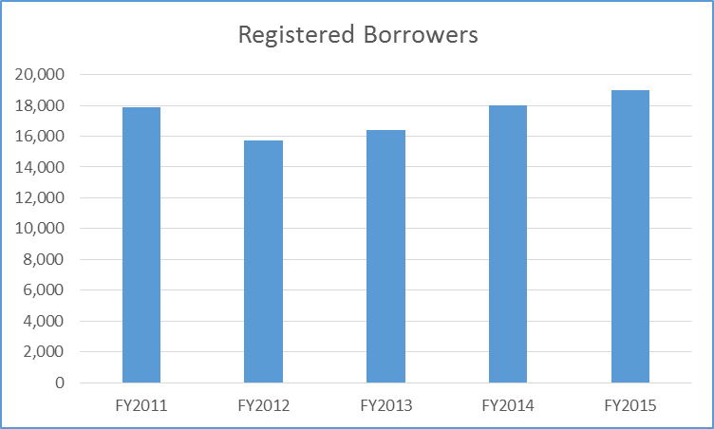

Nearly two-thirds of the city’s residents are library card holders. However, a significantly smaller number actually use the library.

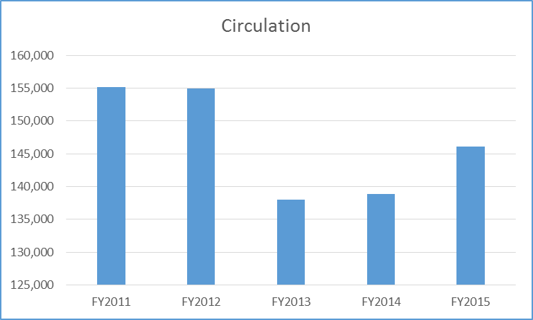

Circulation has declined by half from the highest level in the mid-2000’s, due in part to poor collection management practices and access, i.e. acquisitioning and deaccessioning of materials, physical arranging and cataloging, and shelving practices non-compliant with ADA. Actions to mitigate these issues have been implemented. Where possible, shelving practices are being corrected. Cataloging of non-fiction, audio visual collections has begun. Acquisition methods have been changed to be responsive to user needs and forecasted demands. Necessary deaccessioning has begun in earnest now that the user community has been invited to create a community collection of their favorites, the “Gloucester Picks” program.

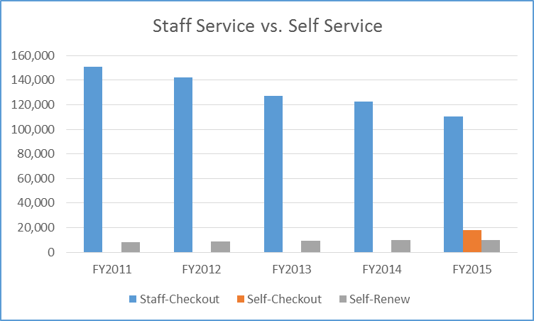

Self-checkout, first offered in the fall of 2014, has been well received by users and has reduced some of the staff’s materials handling activities.

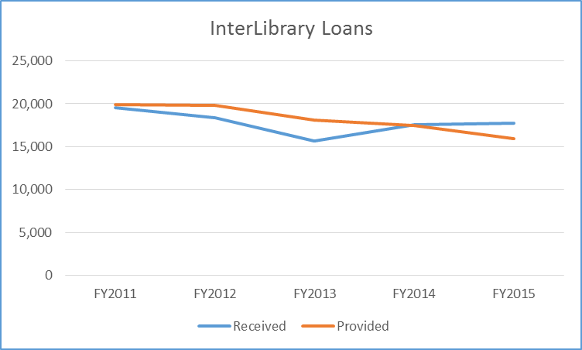

The library was a net lender of materials until FY2014. Becoming a net borrower indicates that the library’s holdings are not meeting the needs of the users. Every effort will be made to reverse this trend as soon as possible.

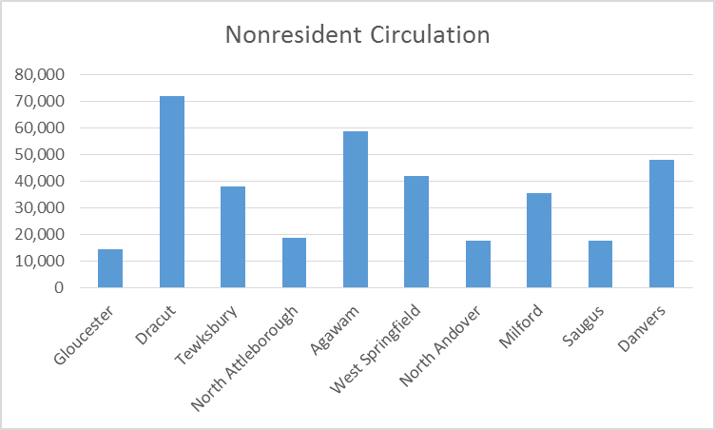

Gloucester is circulating significantly less than its cohorts to nonresidents. Again, this indicates the general lack of demand for Gloucester’s collection, but also, that it is isolated geographically as an island.

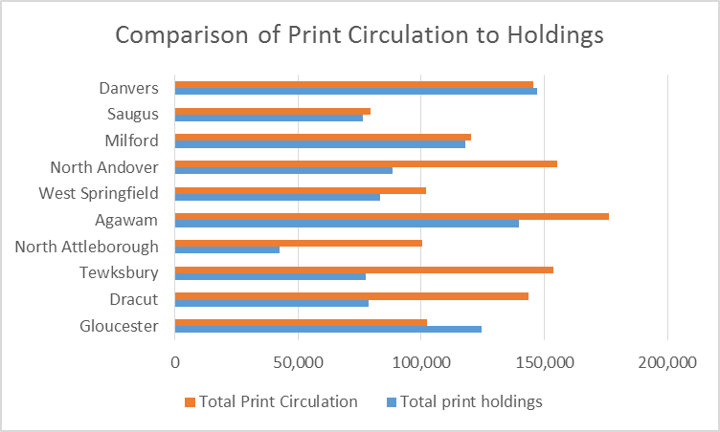

This chart shows the “turn” of the print collections for the ten libraries. Gloucester has the lowest “turn,” but one of the largest collections. This indicates the need to eliminate titles no longer of interest to borrowers. A library with a good working collection would have a “turn” of two or more, meaning circulation is double the holdings, as is the case for North Andover, North Attleborough, Tewksbury and Dracut.

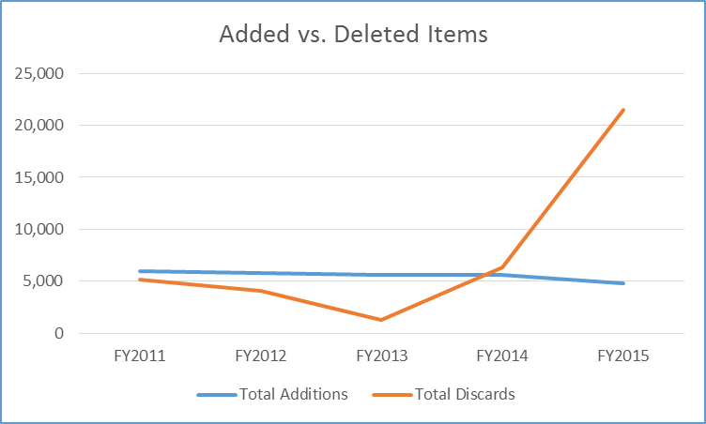

Collection management has a direct effect on circulation. In FY2013 little deaccessioning occurred and circulation dropped significantly. In contrast, deaccessioning increased in FY2014 and FY2015, resulting in an increase in circulation both years. Better and regular collection management will be part of best practices for the library staff.

Holdings of e-books and e-audio books have been increasing over the last 5 years and will continue to increase for the foreseeable future.

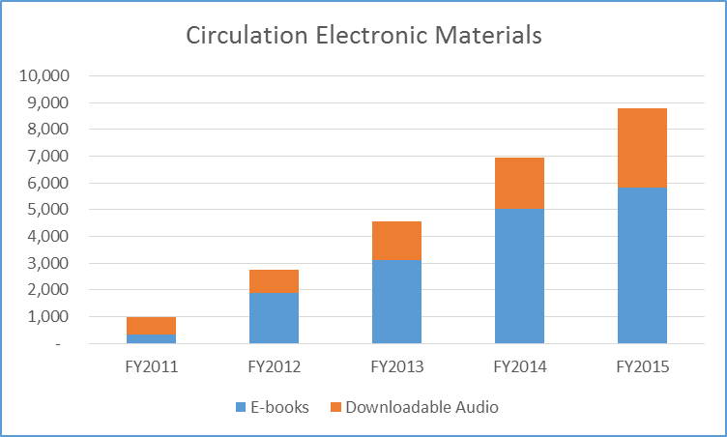

Borrowing of e-books and e-audio books has increased since introduced. We assume demand for these items will continue to rise in the near future. We project that about 25% of the future collection should be electronic, easily accessed remotely anytime.

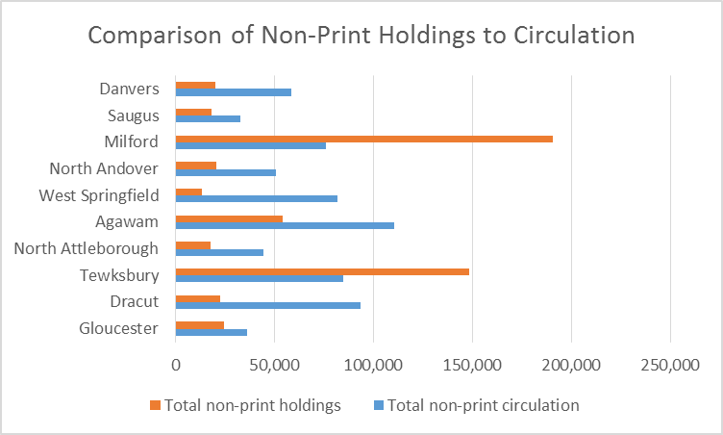

This chart shows the “turn” of the non-print collections for the ten libraries. Gloucester has one of the smaller collections and lowest circulation. Note libraries with smaller collections, North Andover, West Springfield, North Attleborough, and Dracut, exceed Gloucester’s circulation significantly. Clearly, Gloucester needs to promote its electronic resources more effectively.

**Services**

Actual physical use of the library has declined in part due in part to the uncomfortable experiences of users, e.g. exposure to users with serious social problems, lack of materials to meet needs, insufficient new/current materials available on the shelves, inadequate regulation of temperature and humidity, undersized elevator, insufficient parking, and poor customer service. We are working to improve our customer service by doubling staffing at service points, providing the option for self-check, purchasing materials to meet popular demand, and curating a balanced collection to meet the community’s needs.

Meeting room usage was flat until FY015. The change in usage was due to a change in how usage was measured, but also, to the repurpose for public use of three accessible, enclosed areas formerly used by staff only.

**Programs**

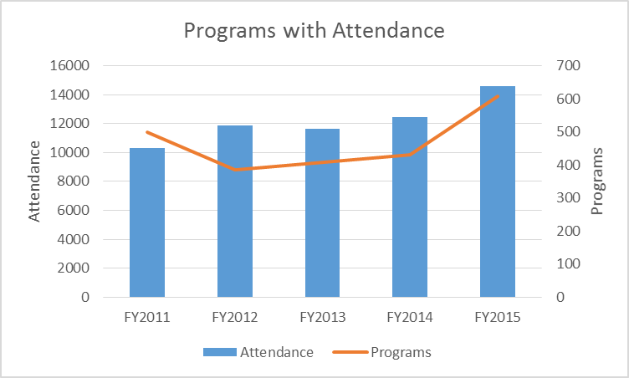

Programming is constrained by lack of availability of program spaces, technological infrastructure, staff capacity and funding.

Children’s programming is well attended and greatly appreciated by all, especially parents of young children. At this time children’s programming is very traditional, mostly story times and crafts with a few performances. Participation is summer reading program is low relative to the size of the community. There is good staff support of several preschools and the public elementary schools.

Teen Services is very constrained by the physical space available. Staff is working to identify types of programming needed and determine the feasibility to deliver the programming without disrupting other library users. Currently, a summer reading program to teens is not offered.

The Lyceum, an all-volunteer committee of the library, provides programs of interest to adults. Adult Services staff began offering a summer reading program, technology-focused classes, and book discussions in restaurants and pubs.

|  |  |  |  |  |  |  |
| --- | --- | --- | --- | --- | --- | --- |
| ARIS FY14 | Programs | Attendance | Meeting Rooms | Meeting  Room Use | Visitors | Dedicated Parking Spaces |
| Gloucester | 430 | 12,435 | 4 | 525 | 135,078 | 2 |
| Dracut | 287 | 6,123 | 1 | 345 | 140,242 | 74 |
| Tewksbury | 707 | 18,711 | 4 | 3,051 | 161,329 | 86 |
| North Attleborough | 176 | 2,858 | 1 | 375 | 108,837 | 0 |
| Agawam | 320 | 6,572 | 2 | 593 | 176,025 | 101 |
| West Springfield | 338 | 8,845 | 2 | 383 | 144,522 | 0 |
| North Andover | 582 | 6,631 | 3 | 923 | 176,385 | 38 |
| Milford | 257 | 6,126 | 2 | 1,230 | 163,132 | 29 |
| Saugus | 557 | 10,109 | 3 | 1,131 | 91,578 | 16 |
| Danvers | 368 | 11,196 | 1 | 351 |  | 54 |

There is a relationship between the availability of parking and facility use; size and accessibility of meeting rooms, and number of staff and programming. Gloucester has 35 dedicated spaces. There is metered street parking surrounding the library in the Downtown, shared by City Hall, YMCA, Cape Ann Museum, religious organizations, funeral homes, and other businesses. Gloucester’s one accessible meeting room is used heavily. Gloucester’s staff has become very creative about using non-traditional open space for programming inside and outside the building.

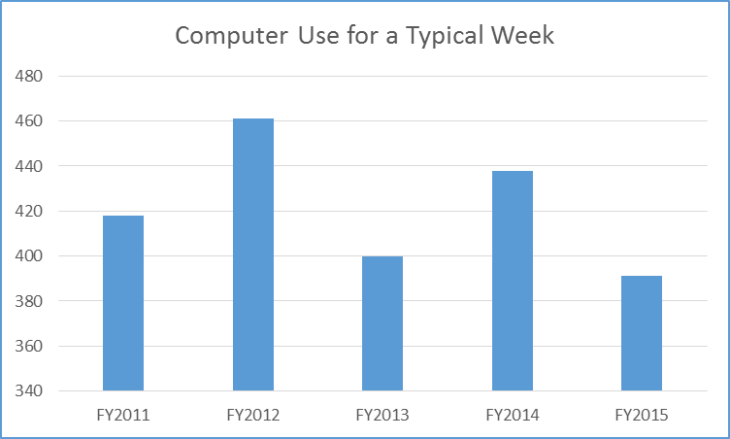

The variation from year to year in internet-enabled workstation usage may be in part due to fluctuations in stability and robustness of the Wi-Fi.

**Activities based on observation during a one week sweep survey, most to least observed.**

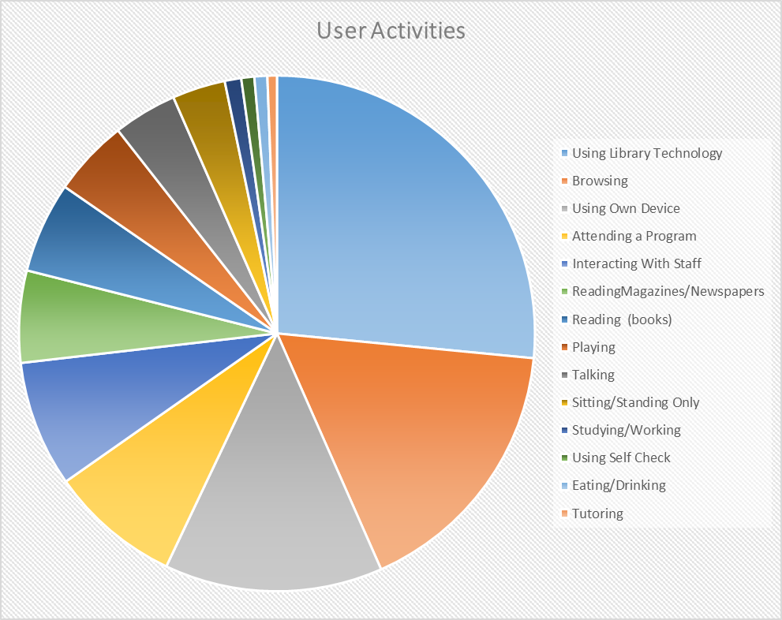

Almost half of all user activity is related to technology. They are using the library’s internet enabled workstations or using their own devices to access the library’s Wi-Fi. There is equal use of the facility as a social space, learning space and a work space. The rest of the use is driven by the library’s collections, programs, and other services.

**Special circumstances for the library and/or community**

Public use of the library building continues to decline. Most potential users are put off by the indigent population that uses the grounds and the library.

The Sawyer Free Library is the only one of the four Cape Ann libraries to still provide professional reference services. The library will become the go-to place and portal for regional information, history and research.

*Library Building Program, Thomas Jewell, July 1999*

Two options were suggested:

One – the library can attempt to renovate and expand upon the existing site.

Two – the library can locate to a new site with ample room for parking and construct a new building that will efficiently meet all of the square foot requirements.

*Library Building Program, Thomas Jewell, Revised September 2004*

Board of Directors rejected option two as impractical (no good alternative publicly owned site was available), too expensive (purchase of a private site, in the unlikely event one became available, would eat up too much of the project budget), and politically impossible (opposition to leaving the Downtown site was overwhelming).

“Starting in 2001 the Board of Directors secured private funds to purchase three adjacent parcels of land to provide sufficient room for expansion and parking*….”*

Through the efforts of the library community, the city was awarded a $4 million grant for public library renovation, expansion and modernization in 2005. However, the community did not vote to approve the referendum on a debt exclusion of $7 million in 2007. Consequently, the city could not accept the state funds.

Since 2005, the Board of Directors has made significant capital investments in the current site. There is a lighted parking lot with thirty-five dedicated spaces and a drive-up book drop, a beautifully landscaped park and garden, and an outdoor amphitheater.

The Community Needs Assessment led to the conclusion that there is still overwhelming opposition to locating the library on a different site. However, it may be more cost effective to build a new library with more flexible space to better meet the community’s future needs on city-owned land.

**A Needs Assessment**

Gloucester needs the library to continue to be an anchor institution in the Downtown campus providing diverse services to residents and visitors. It is a center for literacy, art and culture. However, the existing library building limits the capacity and capability to meet the current and future needs of the city.

The library should be part of the city’s educational infrastructure as the community’s learning commons, an epicenter of information and training with a focus on current computer technologies, workforce development, business start-up and support, local history, and self-directed, participatory learning.

Overall the library building should be aesthetically pleasing, welcoming, comfortable, accessible, flexible, secure, and safe with a robust technological infrastructure and adequate climate controls. Children and their families need separate space for social engagement, learning, and play. Teens and ‘tweens each need their own space with trusted adults present to hang out and/or learn. Adults need quiet spaces to work, study and create and noisy spaces for social activities. All need access to digital technology and tools and opportunities to innovate and create. The community needs a place to gather with free, technology enabled performance, presentation, meeting, learning, and working spaces, both large and small. Visitors need a welcoming place that is intuitive to use with amenities and information.

*Wisconsin Public Library Standards, Fifth Edition, Wisconsin Department of Public Instruction, 2010*

Quantitative Standards by Service Population of 25,000 to 49,999

In 2035 Gloucester’s population is projected to be 24,634

+ the additional population served 2,638

= a service population of 27,273.

FTE Staff 17

Future Need: Basic/Moderate 13.5 Enhanced 16.2 Excellent 18.9

Volumes Held (Print) 92,750

Future Need Basic 76,500 – Excellent 109,000 + e-books

Periodical Titles Received 150

Future Need Basic 146 – Excellent 278 + e-periodicals

Audio Recordings Held 7,400

Future Need Basic 5,300 – Excellent 9,500 + e-audiobooks, e-music

Video Recordings Held 8,800

Future Need Basic 5,800 – Excellent 11,800 + e-content

Public Use Internet Computers 31

Future Need Basic 17 Moderate 21 Enhanced 26 Excellent 45

Collection Size (Print, Audio & Video)

Future Need 111,800

Basic 90,000 Excellent 133,600

**Future Library Capacities Needed**

|  |  |
| --- | --- |
| Print Volumes – Adult | 62,750 |
| Print Volumes – Children | 20,000 |
| Print Volumes – Teen | 5,000 |
| Print Volumes – Tween | 5,000 |
|  |  |
| Periodical Subscriptions – Adult | 110 |
| Periodical Subscriptions – Children | 20 |
| Periodical Subscriptions – Teen | 10 |
| Periodical Subscriptions – Tween | 10 |
|  |  |
| Audio Recordings – Adult | 4,900 |
| Audio Recordings – Children | 1,500 |
| Audio Recordings – Teen | 1,000 |
|  |  |
| Video Recordings – Adult | 4,800 |
| Video Recordings – Children | 2,500 |
| Video Recordings – Teen | 1,500 |
|  |  |
| Fixed Computer Stations – Adult | 20 |
| Fixed Computer Stations – Children | 10 |
| Fixed Computer Stations – Teen | 5 |
| Fixed Computer Stations – Tween | 5 |
|  |  |
| Parking Spaces – Staff | 17 |
| Parking Spaces – Library Patrons | 58 |
| Parking Spaces – Handicapped | 5 |
|  |  |
| Meeting Rooms Seats (Main) | 150 |
| Other Room Seats | 85 |
| Children’s Program Room Seats | 35 |
|  |  |
| Adult Space Seats | 80 |
| Children’s Room Seats | 50 |
| Teen Space Seats | 14 |
| Tween Space Seats | 14 |

The existing library building is not adequate to meet Gloucester’s needs. The following are the community’s suggestions for an improved library facility:

**Comfort**

* Convenient parking
* Less noise
* More children’s space
* More efficient layout
* Reading areas
* Quiet spaces to work
* Niches/Nooks
* Space for tutoring
* Café
* Comfortable chairs
* Lounge for reading
* Chairs with window view

**Accessibility**

* Restrooms on each floor
* Handicapped/elderly access
* More convenient site
* Front door handicapped accessible
* Curbside drop off
* Open to anyone
* A Community center
* ADA accessible
* Easier navigation
* Larger elevator in which wheelchair users can fit and turnabout

**Flexibility**

* More meeting rooms
* Common areas
* Small community rooms
* Conference space
* Place for local artists
* Co-working space
* Multi-generational learning commons
* More gallery space
* AV rooms with green screen and editing tools
* After hours meeting rooms
* Study carrels
* Conference room with projection and virtual meeting capabilities

**Safety and Security**

* Clean furniture
* Updated restrooms
* Restrooms on each floor
* Improved lighting
* Building better maintained
* Safe place for underprivileged children
* Safe, well-ventilated restrooms
* Clean environment
* Less scary restrooms
* Lots of light

**Robust Technological Infrastructure**

* Wi-Fi (Although offered currently, the community may not be aware of this service.)
* Technology needs for research and development
* Gaming
* High-speed internet
* Multiple banks of computers
* Access to the Cloud
* Integrated technology
* Facilities for e-learning
* Meet current technological needs

**Adequate Climate Controls**

* Air conditioning
* Less oppressive air
* Updated green systems
* Modified windows on southwest side to reduce solar impact
* Environmentally friendly
* Improved air quality

**Space Descriptions & Adjacencies**

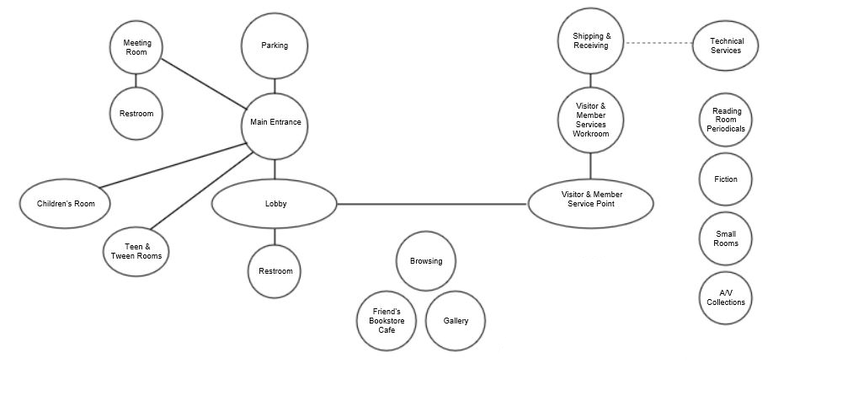**Adjacencies**

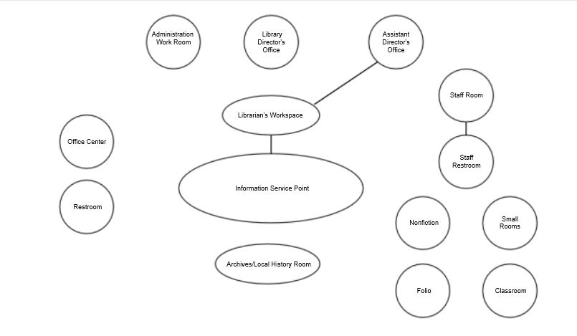

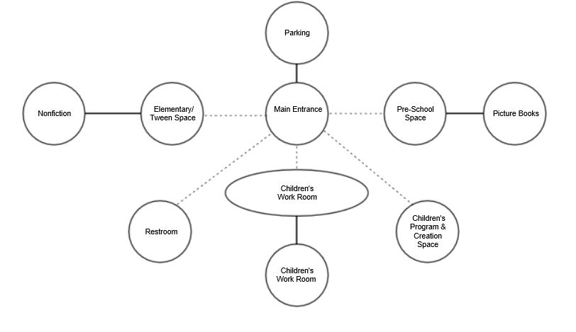

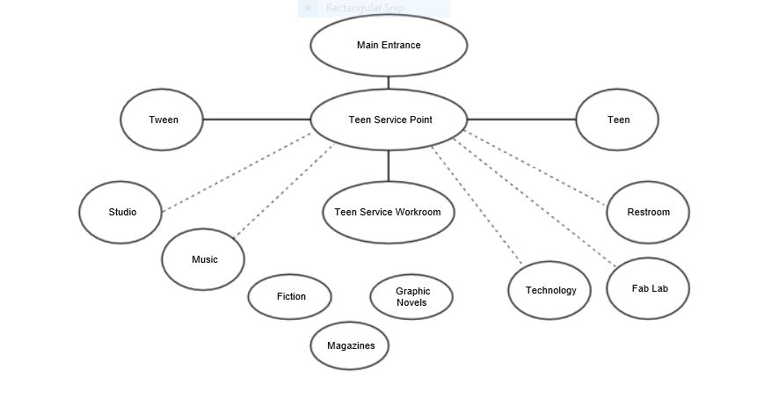

**Space Needs Summary**

|  |  |  |  |
| --- | --- | --- | --- |
| **Spaces** | **Net Square Feet** | **Seats** | **Collections** |
| **S.1:** Administrative Staff Workroom | 440 |  |  |
| **S.2:** Adult Collections – Fiction & Large Print | 3,278 | 40 | 30,000 |
| **S.3:** Adult & Teen Collections - Nonfiction | 3,385 | 42 | 32,000 |
| **S.4:** Archives/Local History Room | 2,995 | 6 | TBD |
| **S.5:** Assistant Director’s Office | 185 |  |  |
| **S.6:** Browsing | 980 | 6 | 12,000 |
| **S.7:** Children’s Service Point & Children’s Room | 4,537 | 50 | 24,000 |
| **S.8:** Conference/Class/Board of Directors Room | 780 | 15-25 |  |
| **S.9:** Creation Spaces | 652 | 19 |  |
| **S.10:** Custodial Closets & Custodian’s Room |  |  |  |
| **S.11:** Director’s Office | 200 |  |  |
| **S.12:** Entrance/Lobby |  | 4 |  |
| **S.13:** Family Restroom |  |  |  |
| **S.14:** Friends Shop & Café | 0-724 | 0-12 |  |
| **S.15:** Gallery | 225 | 2 |  |
| **S.16:** Information & Research Service Point | 451 | 12 |  |
| **S.17:** Large Meeting Room | 1,542 | 100 |  |
| **S.18:** Librarians’ Office | 301 |  |  |
| **S.19:** Office Center | 128 |  |  |
| **S.20:** Parking |  |  |  |
| **S.21:** Public Restrooms |  |  |  |
| **S.22:** Reading Room | 720 | 18 | 110 |
| **S.23:** Small Meeting Rooms | 900 | 36 |  |
| **S.24:** Staff Restroom |  |  |  |
| **S.25:** Staff Room | 300 |  |  |
| **S.26:** Technical Services Workroom | 210 |  |  |
| **S.27:** Teen & Tween Restroom |  |  |  |
| **Spaces** | **Net Square Feet** | **Seats** | **Collections** |
| **S.28:** Teen & Tween Room | 1,621 | 32 | 10,000 |
| **S.29:** Teen & Tween Service Point | 96 |  |  |
| **S.30:** Visitor & Member Service Point | 515 | 4 |  |
| **S.31:** Visitor & Member Services Staff Workroom | 420 |  |  |
| **S.32:** Youth Program/Creation Room | 650 | 50 |  |
| **S.33:** Youth Services Staff Workroom | 420 |  |  |
|  |  |  |  |
| **Sub-Totals** | **25,931 – 26,655** | **446 - 458** | **108,000** |
| **Non-assignable Space 30%** | **7,780 – 7,997** |  |  |
|  |  |  |  |
| **Totals** | **33,711 – 34,652** | **446 - 458** | **108,000** |

**Site & exterior considerations**

The City’s goals related to the site for a library building from *The Community Development Plan for the City of Gloucester, The Cecil Group, Inc., 2001*

Community Focal Points – addresses protection and enhancements of special districts of Gloucester.

* Downtown– recognizes the importance of the downtown to the civic and economic life of the city and provides recommendations to bring renewed resources to its stewards, the Downtown Development Commission and City departments. Downtown is densely developed and populated with only about 5 percent of the city’s land area, it is home to nearly 22 percent of the population and supports almost half of the largest employers. The district should be animated by activity, as the venue for delightful public events and art displays. The adjacent civic center is a pleasant place for the Library, museums, YMCA, City Hall and other resources.
  + Implement improvements, including public restrooms, sidewalks and streetscapes.
  + Maintain diversity of downtown services that attract residents and visitors.
  + Expand opportunities for both market and affordable housing.
  + Develop design guidelines to support a consistent quality of development and protect historic character.
  + Implement a comprehensive traffic and parking management strategy.
  + Improve signage to destinations, attractions, and parking areas.

Public Infrastructure – asserts that public infrastructure should be managed to meet planning goals. The health of the city is determined in large part by the infrastructure that supports it.

* Public Facilities – places high value on quality services to maintain quality-of-life and value to the entire community. It recommends linking decisions on public facilities and services to the larger context of the City’s goals through the Capital Improvement Program.
  + Provide quality facilities and services that meet the fundamental quality of life, and make investments in facilities to promote long-term value.
    - Provide for routine maintenance of existing public facilities and infrastructure to protect their long-term value
    - Develop design guidelines to guide design, use and settings of civic buildings, ensuring that public buildings are located to meet the public’s needs and fit the historic and cultural context.
    - Provide for a centralized public safety building, an updated public library, and public restrooms in the downtown and waterfront sections of the city.
      * The Sawyer Free Library is inadequate for today’s usage. It is not air-conditioned, discouraging use in summer and threatening its valuable collection.
      * The Library serves many civic purposes and has one of the few public meeting rooms in the city.
      * All new, renovated and repaired public buildings should be designed to meet American with Disabilities Act (ADA) standards.
    - Update and maintain educational facilities, including state-of-the-art provisions for technical education.

*Library Building Program, Thomas Jewell, July 1999*

Two options were suggested:

One – the library can attempt to renovate and expand upon the existing site.

Two – the library can locate to a new site with ample room for parking and construct a new building that will efficiently meet all of the square foot requirements.

*Library Building Program, Thomas Jewell, Revised September 2004*

Board of Directors rejected option two as impractical, too expensive, and politically impossible.

“Starting in 2001 the Board of Directors secured private funds to purchase three adjacent parcels of land to provide sufficient room for expansion and parking*….”* Since 2005, the Board of Directors has made significant capital investments in the current site. There is a lighted parking lot with thirty-five dedicated spaces and a drive up book drop, a beautifully landscaped park and garden, and an outdoor amphitheater.

It is difficult for the community to consider other sites for their public library based on emotional attachment and political realities. Considerable investment has been made in the current site, especially parking and landscaping. However, the ideal space allocation for a library building cannot be achieved at the current site: structure 10%, parking, etc. 30%, and landscaping, setbacks, amenities, etc. 60%. It may be more cost effective, meet a greater number of needs, and allow a more flexible facility if a new library were built. There are a few publicly owned parcels of land that should be considered: the Fuller School property off of Blackburn Circle where the YMCA wants to relocate and I4C2 property near the waterfront.

Important criteria that are or could be achieved at the current site:

* Visibility from street
* Access: pedestrian, auto, public transport
* Exterior seating and activity areas
* Parking - The recommended number of parking spaces is 1 space per 400 square feet of building area. The current site has 35 dedicated spaces and metered street parking
* Bike racks – The current site has 2 small racks. The public would like more.
* Garbage cans/dumpsters – The current site has adequate space for a small dumpster, but access is blocked sometimes with illegally parked cars.

Whether other important considerations are achievable at the current site is less clear:

* Soils & geotech
* Safety & security
* Maintenance
* Deliveries
* Outbuildings
* Room for future expansion

**Requirements**

**Accessibility**

The library should be in strict compliance with the latest state and federal ADA requirements and designed for universal access to all services and areas.

Particular attention should be given to:

* Primary and secondary entrances,
* Walks and ramps length,
* Automatic door openers,
* Elevator size,
* Elevator visibility,
* Layout of restrooms,
* Height of drinking fountains,
* Stack aisle widths,
* Stack heights,
* Ambient and task lighting, and
* Appropriate ratio of sitting to standing for OPACs, self-check stations, internet-enabled workstations, and service points.

**Acoustics**

The open space will be noisy, but the building design and building materials should aim to reduce sound travel throughout as much as possible.

* Walls should meet the ceilings
* Soundproofing should be considered for isolated high noise spaces: teen, ‘tween and children’s rooms, program, conference, and meeting rooms, creation spaces, and restrooms.
* Mezzanines and atriums should be avoided.
* Quiet areas separate from noisy, high-traffic areas.

**Aesthetics**

* Architecturally integrated with the historic buildings of the city.
* Reflect the aspirations, arts and culture, and maritime history of the city.
* Inspire future generations.
* Attractive with a comfortable atmosphere that invites use.

**Data & Telecommunications & Electrical**

The library’s technological infrastructure should be modern and robust with a well-designed raceway system.

* Coordination with the City’s IT department will be required to connect the library to the City’s network and telephone system.
* Copper telephone lines installed where needed, e.g. elevator.
* CAT6 cabling and electrical wiring throughout the building with outlets for data and electric in close proximity to each other, adequately distributed to maximize flexible use.
* Secure, ventilated room large enough for the NOBLE library network, City, and Library telecommunications equipment.
* Capacity for efficient wire management
* Wiring hidden but easily accessible by staff
* System for surge suppression to protect equipment.
* Install circuitry for generator
* Provide charging stations for users’ mobile devices.
* Wireless access without building elements inhibiting use throughout.

**Ergonomics**

Workstations for staff should be height adjustable with adjustable keyboards and monitors and appropriate, comfortable, ergonomic, adjustable height task seating and help to minimize repetitive strain.

Materials handling area should have adequate space to stack and maneuver bins with lift assistance.

**Functional areas**

* Expandable for future growth
* General use program room available for use when the library is closed
* Private areas for tutoring and solo working or studying.
* Adequate storage in each area.

**Furniture, fixtures & equipment**

Factors for consideration are usefulness, flexibility, movability, comfort, age-appropriateness, and fire code compliance.

* Service points should be small, mobile, impermanent, kiosk style
* High density, light weight, stackable chairs and mobile, flip-top tables for larger meetings.
* Task chairs with wheels for computer workstations and conference rooms.
* Sturdy tables with two to four seats for individual or small group work with integrated task lighting, outlets and USB ports.
* Soft, durable single seats designed to move easily for adults and teens.
* Children’s
  + Soft seating to accommodate a care provider and child together.
  + Child sized furnishings.
  + Consider adjustable height tables
  + Sturdy chairs with backs that will not catch children’s feet.
* Shelving
  + Shelving not more than 5 high, 72 inches.
  + Stack runs no longer than 18 feet, 9 feet ideally.
  + As many mobile shelves as possible to allow more flexibility in high use and possible programming areas, e.g. children’s room.
  + Consider tablets built into the end panels to connect users to electronic collections.
* Portable storage units

**HVAC**

* Efficient.
* Expandable to accommodate increased occupancy.
* Easily maintained and repaired.
* Convenient access to mechanical rooms and roof top units.

**Lighting & Electrical**

The entire library should have the most energy efficient, low maintenance, humanly comfortable lighting for the tasks being performed. Natural light wherever appropriate and possible.

* Stack lighting should be uniform for all shelves. Usually this is accomplished by a variety of methods: lighting fixtures that run perpendicular to stacks; stack canopy tops and end panels that don’t block light; wide enough stack aisles; natural light.
* LED lighting using the same bulbs throughout
* Automatic sensors of the amount of natural lighting available and adjustment system based to regulate the amount of artificial light provided should be included.
* Low traffic areas should have motion/occupancy sensors that automatically turn off lights.
* Dimmers should be installed in all areas where there may be the need to vary the illumination, e.g. program, conference, and meeting rooms.
* Reading and work areas should have task lighting and electrical and data outlets available.
* Emergency lighting system and generator hookup should be part of the lighting plan.
* Scaffolding or other special equipment should not be required to change bulbs
* Sufficient power for HVAC systems

**Security**

The library needs to be designed for safe use by everyone in the community from preschoolers to elders.

Particular attention should be given to:

* Clear sight lines,
* Less dense, lower shelving near the entrance, and
* Glass enclosed, externally lockable rooms for separate activities: quiet or collaborative work.

Recommendations include:

* Keyless entry for exterior entrances and restrooms and a master lock plan for entire facility
* Surveillance cameras and motion detectors with monitoring capability.
* Panic alarms at public service areas and remote staff areas to summon public safety personnel.
* Paging system to summon support staff.
* Full compliance with the fire code with respect to fire alarms, smoke and heat detectors, fire suppression systems, fire doors, exit signs, emergency lighting etc.
* Service point on every floor.

**Signage**

* Clear floor plans with emergency exits designated.
* Use of color to provide connection and direction to specific spaces.
* Multilingual in the community’s languages, e.g. English, Spanish, Italian, Portuguese

**Site**

* Conveniently located, with high visibility
* Access by public transportation, sidewalks, private vehicles – cars and bikes
* Adequate space for on-site parking

**Sustainability**

Create a “green” facility. Design for highest LEED certification.

* Minimize impervious surfaces.
* Install low-flow water devices
* Native species landscaping
* Use non-potable water for irrigation
* LED lighting throughout
* Solar sensitive light fixtures
* Maximize passive and natural sources of heat, cooling, ventilation, and light
* Enable the building and grounds to be used for non-library activities
* Building envelope and systems designed to maximize energy performance
* Use locally sourced materials
* Construct with materials, methods and systems that ensure healthy indoor air quality
* Consider a green roof or cool roof.

**Windows**

* Good views
* At eye level
* Operable for ventilation between seasons
* At least double, if not triple pane windows with appropriate window treatments.
* Windows that take advantage of solar gain in cold weather and control solar radiation in hot weather.